Display Open/Close on Leg Description on Order Details window.

Enhancement
Display Open/Close on Leg Description on Order Details window.

Test Procedure
- Start any Trader GUI or OMT GUI, and bring up the Market Display window.
- Add several strategy orders, using various values (open, close, neither) for “Pos. Eff.” In the “Leg Details” box in the lower left corner of the “Add New Order” dialog. You can set different “positon effects” values for different legs for the same order.

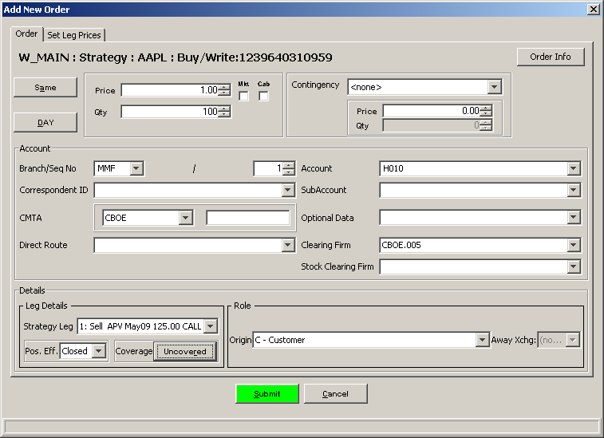

- Bring up the “Order Status” window for strategy orders.
- Select an order, and bring up the “Order Details” window.
- Verify that the stragey legs (displayed just below the report header) include “Open”, “Closed”, or “N/A” (for “Neither”), and match the position effects that you selected for each leg when you entered the order. (The default, for any leg that you did not change, is “Open”.)
- Repeat steps 4 and 5 for each of your orders.

Example of how the Order Detail report should look:

